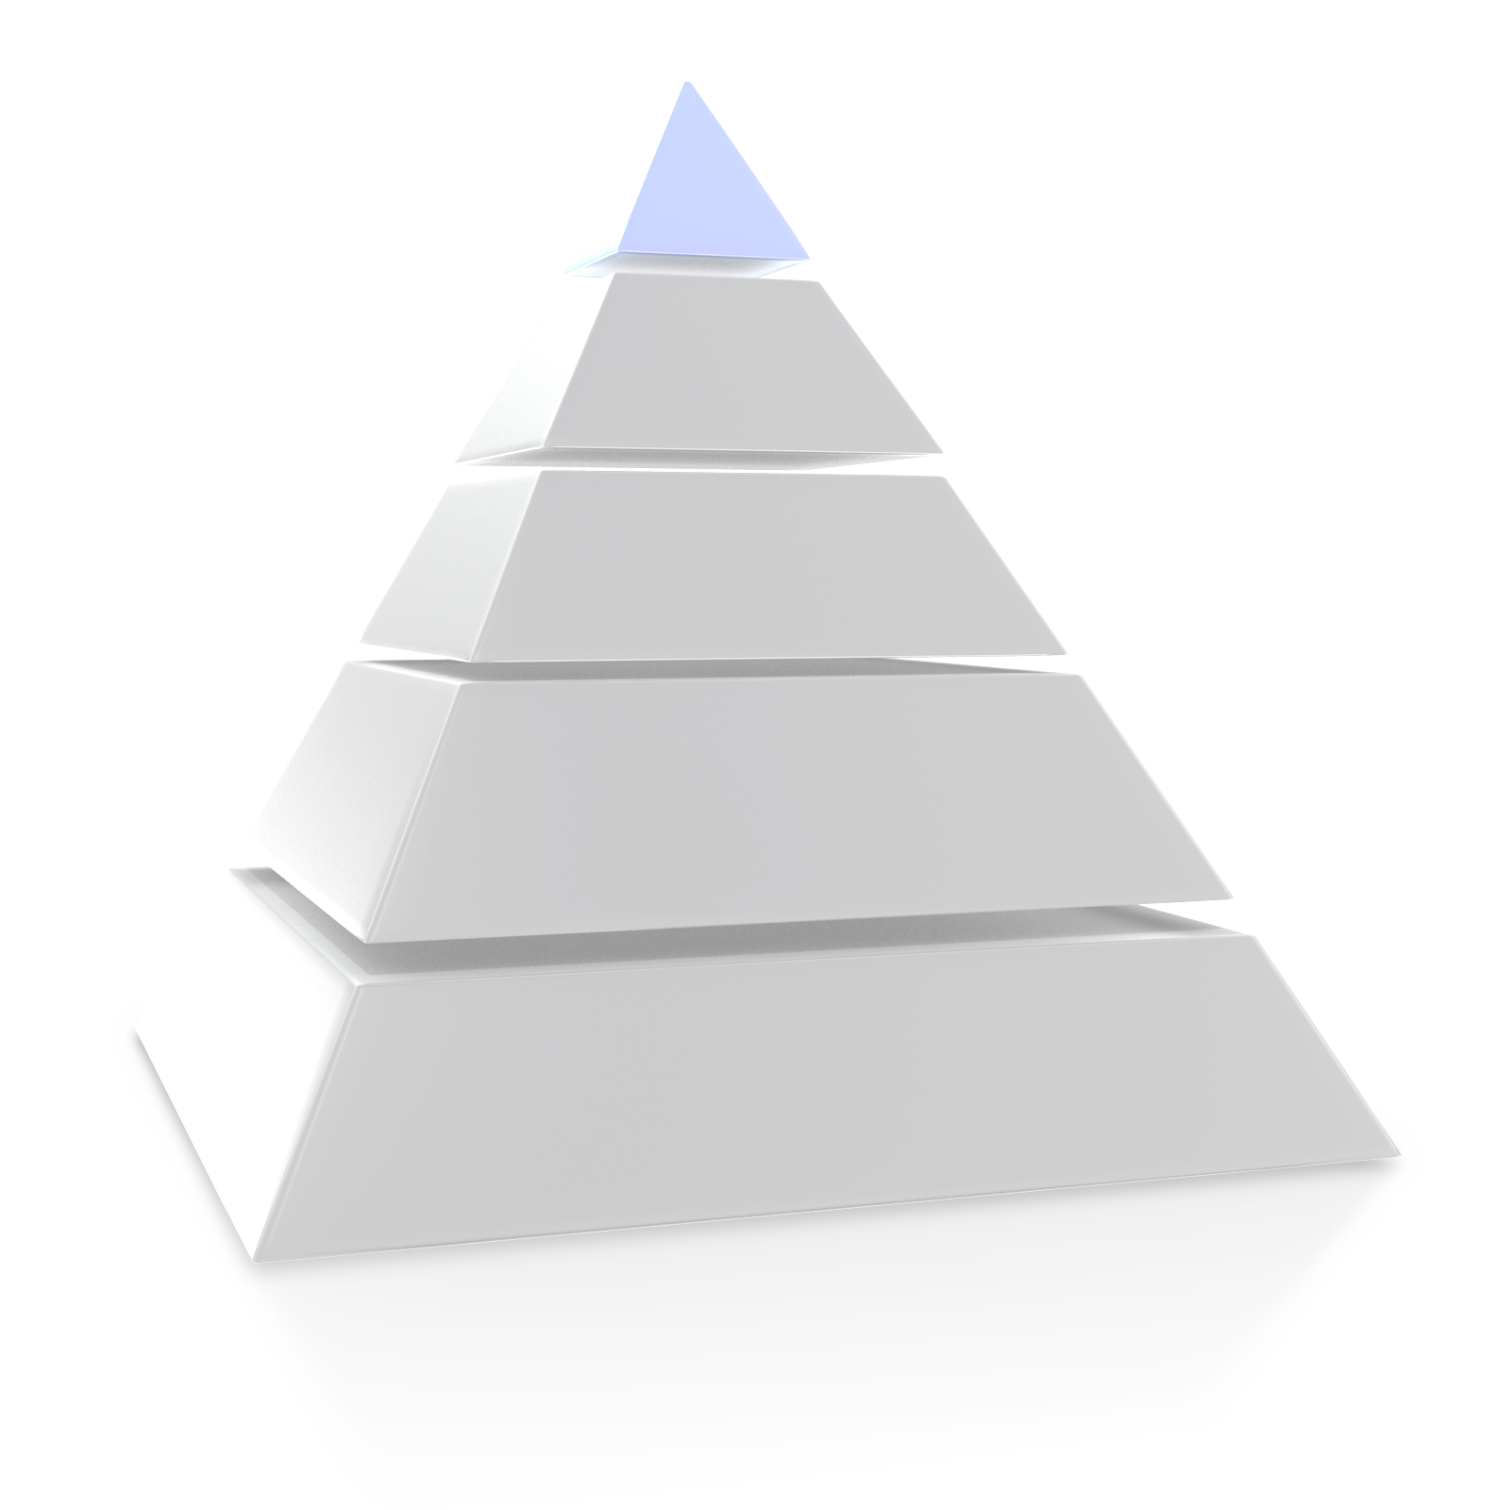
Words
& Phrases
Tone
or Language
Craft Elements
Structure
Theme
Title Analysis Pyramid
Words and Phrases

What words and phrases play an important role in communicating the Author’s message?

- The Author uses words like… because….
- Words like… and …represent the text because…
- These words ad to the text by…
Tone or Language

What is the feeling or attitude communicated through the poem? What language is used to create this feeling?

- The overall tone of the text is
- I know this because
- The author probably chose to use that tone because…
Craft Elements

What craft elements do you notice that play a role in the author’s purpose
(figurative language and sound devices)?

- The author uses… because…
- These elements help the reader understand…
Structure

What structural elements do you notice? (Stanzas, Rhyme Scheme) How are the ideas organized throughout the poem?

- The author organizes the text by…
- I know this because …
- The author probably organized the text this way because…
Theme

What is the author’s message about life that he/she is sending the audience through this poem?

- The theme of the poem is…
- I know this because…
- The author probably chose to express this theme because…

