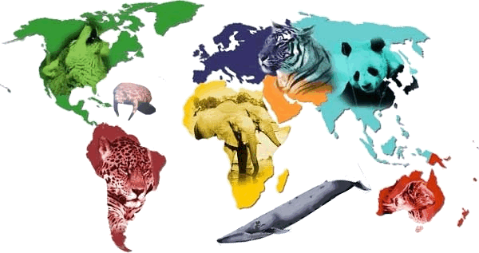
Endangered Species Brochure Content Template

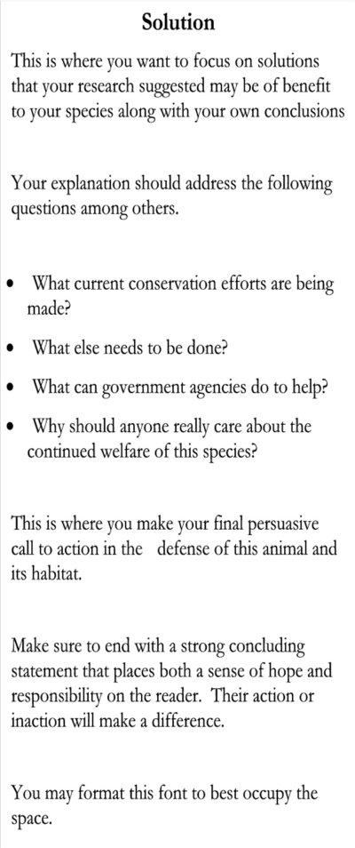
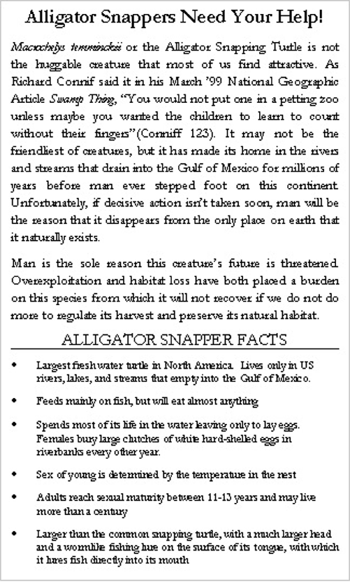
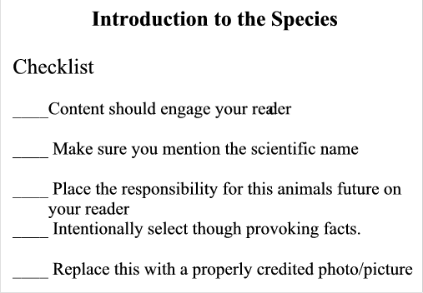
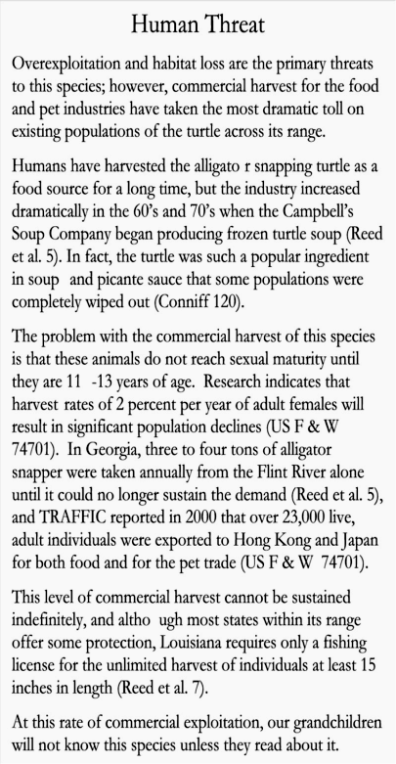
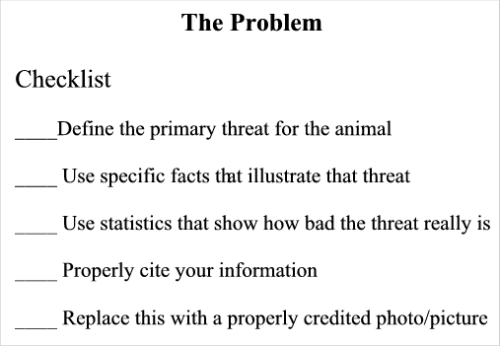
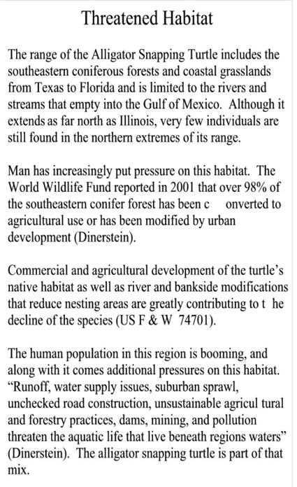
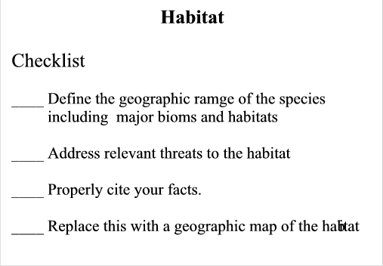
The template below addresses the content focus for each of the four major content areas of the project. The Front Cover and the Works Cited sections are not included. Review the sample information for each section along with the checklist for each section. Both should give you some perspective on the kinds of information you need to pursue in your own research for each section of the required content. Use the other side of this template to begin formulating questions to pursue in your own research based on the general information you find on your
animal and based on the content required for each section.

Question for Direction: Initial Background Research for Question Development
Introduction to the Species

This is where you introduce your species and the challenges it faces for its future. Your content must contribute to your reader’s interest and sympathy by combining some general background with interesting and thought provoking facts.

This section will also contain the equivalent of your thesis statement.

Attack the Issue!
The Problem

This is where you define the primary factors that are threatening the survival of your species. Search for very specific information that shows just how bad the problem really is.

Learn the terms that are used to describe the problem and find examples in your research that paint a measurable picture of the impact that this problem will have on the future of your species if action isn’t taken. (The needed action will relate to Solutions you suggest in the last section.)

Bring It!

Habitat

This is where you describe the biome where this animal lives. You should become an expert on both the place and the challenges for animals living in this place. You will go beyond your species here and focus on the land or marine environment.

Habitat loss is a contributing factor for many endangered species. Look for statistics that show just how much of a problem this may be for your species.

Bring It!
Solutions

This is where you show your reader what is currently being done to help your animal and why even more needs to be done. Use the work of conservation organizations for this animal and its habitat to suggest solutions that will make a difference.

Finish with a thought provoking point addressing why your reader should care enough to actually become involved and do something that will make a difference.

Close the Deal!

Name: _______________________

Species: ______________________
The first thing you need to do whenever you begin a research process is to familiarize yourself with general information on your subject. Consider the content areas below that your project will need to develop. Then, select a general reference source on your animal and read it. As you read, consider what you now know and what you need to find out with additional research. Record questions that you need to answer with additional
research in each of the following areas. You need several specific questions in each area to drive your initial research.

