The Call of the Wild
Name: ______________________

Date: ______ Class: ___________
Chapter 6 and 7 Study Guide

Buck is changed by his relationship with John Thornton. Use the diagram below to characterize the relationship and some of the major events that illustrate Bucks devotion to his master.

Use adjectives in the boxes to
______________________________________________________________________________________________________________________________________________________________________________________________
_____________________________________________________________________________________________________________________________________________________________________________________________
describe the relationship between
Buck and John Thornton

What binds these two characters?

1. How is Buck changed by this
_________________________________________________________________________________________________________________________________________________________________________________________________________________________________________________________________________________________________________________________________________________________________________________________________________________________________________________________________________________________________________________________________________________________________________________________________________________________________________________________________________________
new relationship with Thornton?

2. Use the boxes below to summarize the significant events and to note the characteristic of Buck’s relationship to Thornton that is highlighted by each experience.

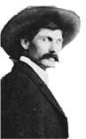
Circle City Forty Mile Creek
___________________________________________________________________________________________________________________________________________________________________________________________________________________________________________________________________________________________________________________________
___________________________________________________________________________________________________________________________________________________________________________________________________________________________________________________________________________________________________________________________

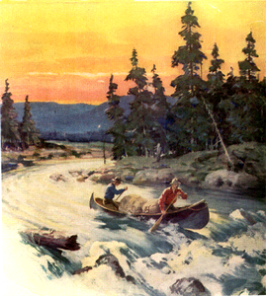

The Eldorado Saloon
_______________________________________________________________________________________________________________________________________________________________________________________________________________________________________________________________________________________________________________________________________________________________________
_

Chapter 7

3. The more time Buck spends with Thornton the closer his wild instincts come to the surface. Why?
How is his new lifestyle with Thornton reflected symbolically in the dream of the caveman?
_______________________________________________________________________________________________________________________________________________________________________________________________________________________________________________________________________________________________________________________________________________________________________________________________________________________________________________________________________________________________________________________________________________________________________________________________________________________________________________________________

- After his encounter with the wolf, what forces are pulling Buck in two different directions? Which one do you think will win? Explain
_______________________________________________________________________________________________________________________________________________________________________________________________________________________________________________________________________________________________________________________________________________________________________________________________________________________________________________________________________________________________________________________________________________________________________________________________________________________________________________________________

- Which one of the themes we listed at the beginning of this novel do you think contributes the most to how this story ends? Explain, using specific support from the story.
__________________________________________________________________________________________________________________________________________________________________________________________________________________________________________________________________________________________________________________________________________________________________________________________________________________________________________________________________________________________________________________________________________________________________________________________________________________________________________________________________________________________________________________________________________________________________________________________________________________________________________________________________________________________________________________________________________________________________________________________________________________________________

