The Call of the Wild
Name: _______________________

Date: __________ Class: _______

Chapter 4 Study Guide

Many of you did an extremely accurate job of predicting how Chapter 3 would end. Based on those events, let’s see how well you can predict how Chapter 4 will begin. Complete the box below with your detailed prediction of how this chapter will begin now that Spitz has been eliminated from the team.
_________________________________________________________________________________________________________________________________________________________________________________________________________________________________________________________________________________________________________________________________________________________________________________________________________________________________________________________________________________________________________________

Were you correct? Yes Partially No

If yes, explain how you knew what to expect? If no, explain what threw you in another direction? If partially, touch on both how you knew and what surprised you. Explain.
______________________________________________________________________________________________________________________________________________________________________________________________________________________________________________________________________________________________________________________________________________________________________________________________________________________________________________________________________________________________________________________________________

What does Buck’s physical reaction to
Francois’s choice for lead dog tell you
about what is going on in his mind?
Write your response in 1st person.

- As you read this chapter, you should notice that Buck’s relationship with humans has changed significantly since the beginning of the novel. Use the graphic below to note the characteristics of each relationship. What can you infer about Buck from these changes?
Judge Miller
____________________________________________
Francois & Perrault
(Heading towards Dawson)
____________________________________________
Francois & Perrault
(Heading back to Dyea)
____________________________________________
Scotch half-breed
(Work on the Mail Train)
____________________________________________
Civilized World
Primitive World

______________________________________________________________________________________________________________________________________________________________________________________________________________________________
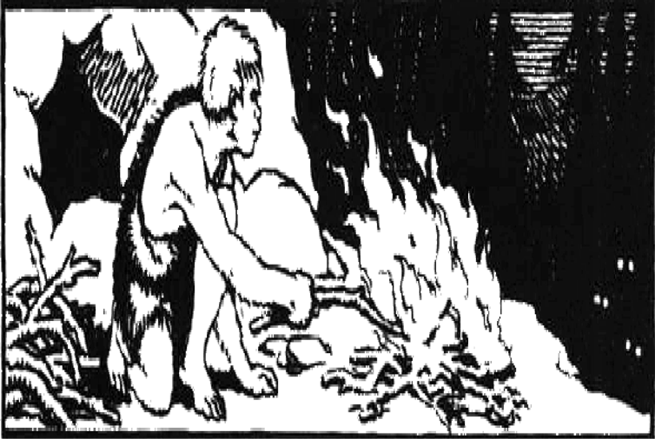
- What is the significance of Buck’s increasingly vivid vision of the cave man? Examine the paragraph below written in response to this question. Underline the sentence that does not support the topic sentence highlighted in bold print. Explain your choice.

Buck’s waking dream of the cave man represents the awakening of his primitive instincts in response to his continuing contact with this primitive environment. 1. As Buck continues to adapt to the northland environment, his relationship with his owners continues to become more primitive. 2. The vision of the cave man and his primitive surroundings seems to represent an ancient memory passed down through the generations. 3. He sees himself at the fire in the presence of man’s primitive ancestor and feels the fear that the cave man felt for the constant danger that lurked just beyond the light of the fire. 4. The vision seems as real to Buck as the cook’s interruption of the dream in the present world. 5. The cook of course thinks he is merely awaking Buck from a bad dream, and he has no idea of what Buck is really experiencing. 6. Buck is changing, and the dream is a connection between the ancestral forces within him and the environment in which he now finds himself. 7. Somehow he envisions that ancient relationship between primitive man and primitive dog, and somehow he is connecting to that relationship. 8. As Buck continues to adapt to this new world, this dream is bound to reflect those adaptations. 9. The question is where it will ultimately take him.
____________________________________________________________________________________________________________________________________________________

- Examine what happens to Dave. Explain why you think he refuses to be separated from the team? Is this something that could happen to Buck for the same reason? Explain.
__________________________________________________________________________________________________________________________________________________________________________________________________________________________________________________________________________________________________________________________________________________________________________________________________________________________________________________________________________________________________________________________________________________________________________________________________________________________________________________________________________________________________________________________________________________________________________________________________________________________________________________________________________________________________________________________________________________________________________________________________

