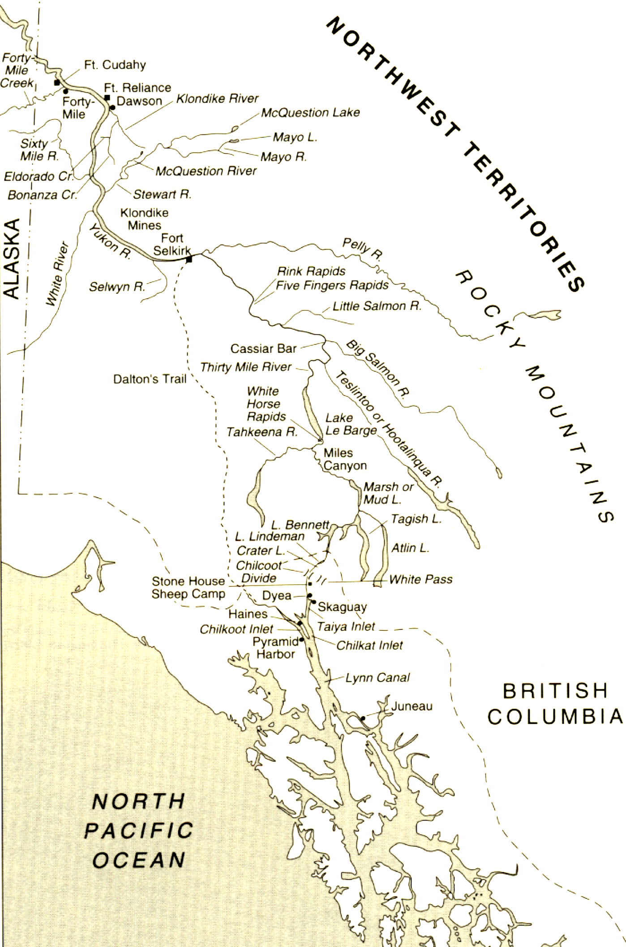
Use the map to identify where important events take place during Buck’s travels in the Klondike Territories

__________________
__________________
__________________
__________________
__________________
Buck kills Spitz .
__________________
__________________
__________________
__________________
__________________

__________________

__________________
