The Call of the Wild
Name: _______________________

Date: __________ Class: _______

By Jack London Chapter 1 and 2 Study Guide

Objectives: As we read the novel, we will focus on the literary concept of theme, vocabulary expansion, and the grammar concepts related to the development of compound and complex sentences. The themes listed below will drive our examination of the novel.

A theme within a piece of literature is an insight about life or human nature that the writer presents to the reader through the characters and their experiences in the story. Keep your eyes out for evidence that London is expressing the following themes as we read.

1. Survivors are those who adapt to changing circumstances.
2. Experience is the greatest teacher.
3. The urge to survive is ultimately more powerful
than the moral law of human civilization.

Use the chart below to help you keep track of the characters as they are presented in the story.

Character | Relationship to Buck / Influence of this character on Buck

Judge Miller
Manuel
The Man in the red Sweater
Perrault
Francois
Curly
Dave
Spitz
Billee
Joe
Sol-leks
Pike
Dub

Use the space included for each question to bullet related passages from the story and to note your observations about each issue.

- What is the lesson that Buck learns from the man in the red sweater? Why might it be very important to his survival in this new environment?
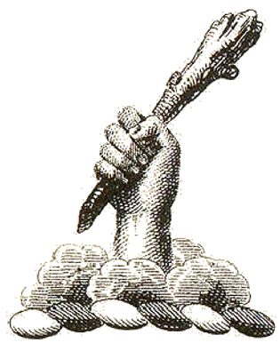
________________________________________________________________________________________________________________________________________________________________________________________________________________________________________________________________________________________________________________________________________________________________________________________________________________________________________________________________________________________________________________________________________________________________________________________________________________

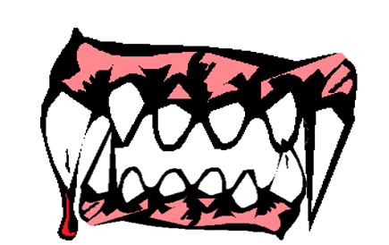
- What does Buck learn from Curly’s experience with the pack of huskies that is equally important to his own survival in this new environment?
________________________________________________________________________________________________________________________________________________________________________________________________________________________________________________________________________________________________________________________________________________________________________________________________________________________________________________________________________________________________________________________________________________________________________________________________________________

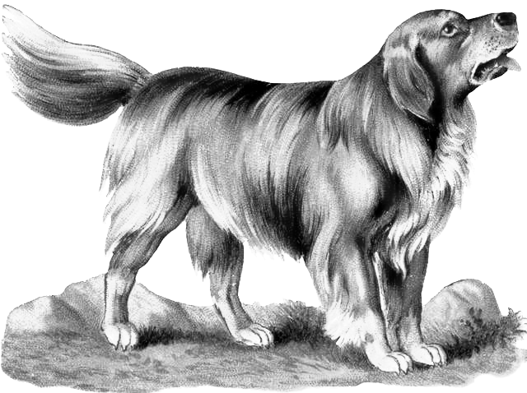
Use the space below to make note of the change that Buck is experiencing as a result of his sudden relocation to a new and strange environment.
Buck possesses several characteristics that may help him survive and adapt to his new environment.
_______________________________________________________________________________________________________________________________________________________________________________________________________________________________________________________________________________________________________________________________________________
Buck begins to shed some characteristics.
_______________________________________________________________________________________________________________________________________________________________________________________________________________________________________________________________________________________________________________________________________________
What skills and adaptations develop as a result of his relocation to this environment?
_____________________________________________________________________________________________________________________________________________________________________________________________________________________________________________________________________________________________________________________________________________________________________________________________________________________________________
What can you infer about Buck based on this metamorphosis?
_______________________________________________________________________________________________________________________________________________________________________________________________________________________________________________________________________________________________________________________________________________

