The Call of the Wild
Name: _______________________

Date: __________ Class: _______
Chapter 3 Study Guide

As you begin to read Chapter 3, you should quickly begin to get a sense for how it must end. This is because Jack London masterfully combines Buck’s interaction with the setting’s harsh conditions and his interaction with other characters to build up to an unavoidable climactic scene. Buck continues to adapt and continues to learn, but something else stirs within him as well. Use the diagram below to track the events that not only prepare Buck for the climactic end of the chapter, but also suggest to the reader exactly how the chapter must end.
After reading the opening scene with the starving huskies, how do you think the chapter is going to end? Why?
____________________________________________________________________________________________________________________________________________________________________________________________________________________________________________________________________________________________________________________

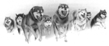
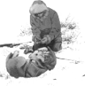
The battle with the starving huskies
___________________________________________________________________________________________________________________
1
The six day struggle to get up the
Thirty-Mile River
___________________________________________________________________________________________________________________________________________________________
2

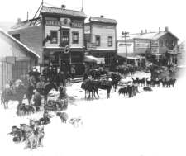
The week’s rest in Dawson

____________________________________________________________________________________________________________________________________________________________
4
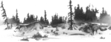
The “Dolly” experience and aftermath
___________________________________________________________________________________________________________________________________________________________________________________________________________
3

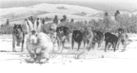
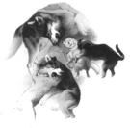
The chase of the white wraith
_______________________________________________________________________________________________________________________________________________________________________________
5
You title the climactic scene.
__________________________________________________________________________________________________________________________________________________________________________________________________________________________________
The Dominant Primordial Beast
6

Answer the questions below in paragraph form. Make sure each response begins with a strong
topic sentence that is supported with specific evidence. If you prefer, you may choose to draw a
detailed illustration in response to the questions. If you choose this option, your illustration should
just as clearly answer the question and integrate one of your vocabulary words into the drawing.
Complete your drawing on a separate sheet of clean paper and include the question at the top of
the illustration.

- Why are the starving huskies such dangerous enemies? Explain.
_______________________________________________________________________________________________________________________________________________________________________________________________________________________________________________________________________________________________________________________________________________________________________________________________________________________________________________________________________________________________________________________________________________________________________________________________________________________________________________________________________________________________________________________________________________________________________________________

- Why does Buck begin to covertly disrupt the solidarity of the team? What is this behavior really about, and what does it suggest about Buck? Explain.
_______________________________________________________________________________________________________________________________________________________________________________________________________________________________________________________________________________________________________________________________________________________________________________________________________________________________________________________________________________________________________________________________________________________________________________________________________________________________________________________________________________________________________________________________________________________________________________________

Character Notes – The Continuing Metamorphosis
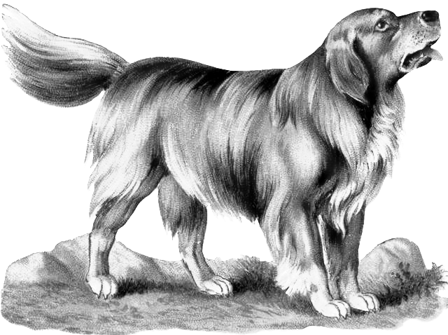
Buck continues to change as a result of experiences and as a result of his continuing contact with his new environment. Use the diagram below to note the impact of his continued metamorphosis.
What personality traits develop as a result of his continued contact with this environment?
_______________________________________________________________________________________________________________________________________________________________________________________________________________________________________________________________________________________________________________________________________________
What physical traits develop as a result of his continued contact with this environment?
_______________________________________________________________________________________________________________________________________________________________________________________________________________________________________________________________________________________________________________________________________________
What can you infer about Buck based on these changes?
_______________________________________________________________________________________________________________________________________________________________________________________________________________________________________________________________________________________________________________________________________________

